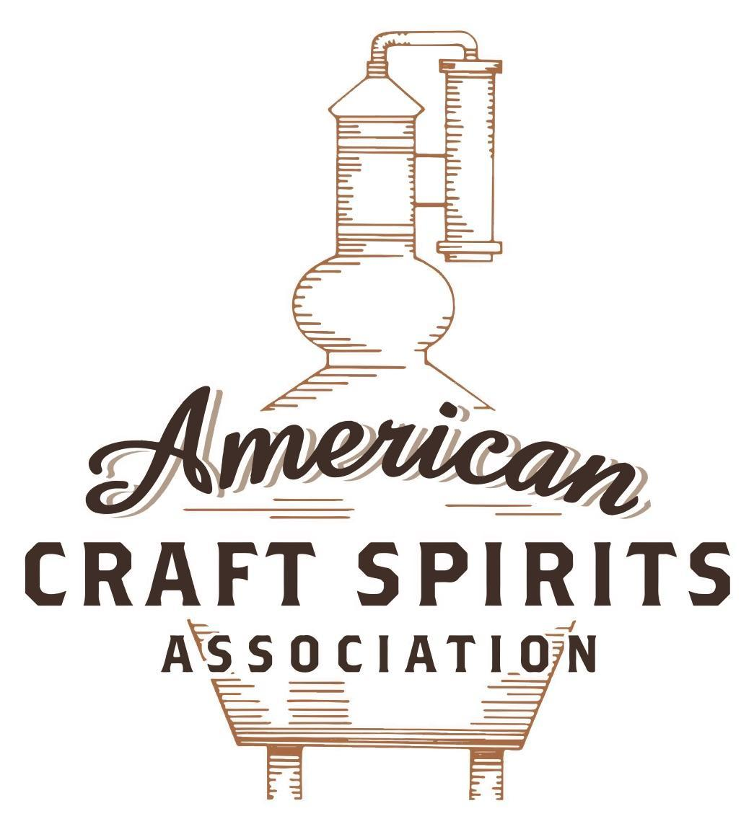
Spirits DtC Shipping Guide

This guide summarizes the direct-to-consumer shipping rules for distilleries in all 50 states and D.C. and also addresses the measures state governments have taken to ease delivery and shipping restrictions during the COVID-19 pandemic.

DtC Quick Guide Comparison

Out-of-State Distilleries  Can Ship Into State? |  |  |  | In-State Distilleries  Can Ship Within State?
State | Yes | No |  | State | Yes | No
AL |  | X |  | AL |  | X
AK | X |  |  | AK | X
AZ | X |  |  | AZ | X
AR |  | X |  | AR |  | X
CA |  | X* |  | CA |  | X*
CO |  | X |  | CO |  | X
CT |  | X* |  | CT |  | X
DE |  | X |  | DE |  | X
DC | X |  |  | DC | X
FL |  | X |  | FL |  | X
GA |  | X |  | GA |  | X
HI |  | X* |  | HI |  | ?*
ID |  | X |  | ID |  | X
IL |  | X* |  | IL |  | X*
IN |  | X |  | IN |  | X
IA |  | X* |  | IA |  | X*
KS |  | X |  | KS |  | X
KY | X |  |  | KY | X
LA |  | X |  | LA |  | X
ME |  | X* |  | ME |  | X*
MD |  | X |  | MD |  | X
MA |  | X |  | MA |  | X
MI |  | X |  | MI |  | X
MN |  | X |  | MN |  | X
MS |  | X |  | MS |  | X
MO |  | X |  | MO |  | X
MT |  | X |  | MT |  | X
NE | X |  |  | NE | X
NV |  | X* |  | NV |  | X
NH | X |  |  | NH |  | X*
NJ |  | X* |  | NJ |  | X*
NM |  | X |  | NM |  | X
NY |  | X* |  | NY |  | X*
NC |  | X |  | NC |  | X
ND | X |  |  | ND | X
OH |  | X |  | OH |  | X
OK |  | X |  | OK |  | X
OR |  | X |  | OR | X
PA |  | X* |  | PA |  | X
RI |  | X* |  | RI |  | X
SC |  | X |  | SC |  | X
SD |  | X |  | SD |  | X
TN |  | X |  | TN |  | X
TX |  | X |  | TX |  | X
UT |  | X |  | UT |  | X
VT |  | X |  | VT |  | X
VA |  | X |  | VA |  | X
WA |  | X* |  | WA | X
WV |  | X* |  | WV |  | X*

WI |  | X |  | WI |  | X
WY |  | X |  | WY |  | X

Notes:
*CA: If passed and signed into law, Senate Bill 620 would allow licensed distilled spirits producers in states other than California and licensed distilled spirits manufacturers or craft distillers in California who obtain distilled spirits direct shipper permits to ship directly to consumers in California
*CT: Consumers with appropriate permit may receive alcohol shipments
*HI: Consumers with appropriate permit may receive alcohol shipments; If passed and signed into law, Senate Bill 65 would allow licensed distilled spirits manufacturers in Hawaii and in states other than Hawaii who obtain direct shipper permits to ship directly to consumers in Hawaii
*IL: If passed and signed into law, Senate Bill 0532 would allow licensed distilled spirits producers in Illinois and in states other than Illinois who obtain distillery shippers’ licenses to ship directly to consumers in Illinois
*IA: If passed and signed into law, House File 639 would allow native distilled spirits manufacturers in Iowa and in states other than Iowa who obtain direct shipper permits to ship directly to consumers in Iowa and to consumers in states other than Iowa
*ME: If passed and signed into law, Legislative Document 1358 would allow distilleries outside of Maine with current manufacturer licenses and distilleries licensed in Maine who obtain spirits direct shipper licenses to ship directly to consumers in Maine
*NJ: (1) If passed and signed into law, Assembly Bill 3167 would allow a craft distillery licensees to ship no more than 9 liters of distilled spirits to a consumer in New Jersey; (2) If passed and signed into law, Senate Bill 3020 would allow craft distillery licensees in New Jersey or in states other than New Jersey to ship no more than 20 liters of distilled spirits to a consumer in New Jersey via common carrier
*NV: Licensed individuals can import one gallon per month of spirits for personal use and the out-of-state supplier must pay excise tax
*NH: If passed and signed into law, Senate Bill 125 would allow licensed liquor manufacturers who obtain direct to consumer shipping permits from the commission to ship directly to consumers in New Hampshire
*NY: Consumer may import up to 90L of liquor per year for personal use without a license; If passed and signed into law, Assembly Bill 3275 would allow licensed liquor manufacturers in states other than New York and licensed distillers and farm distillers in New York to ship no more than thirty-six cases (no more than nine liters per case) of liquor to consumers in New York
*PA: Consumer may place a special liquor order and distiller must ship to a PLCB-operated store
*RI: Distiller can only ship to customer if order was personally placed by customer at distiller's premises
*WA: If passed and signed into law, House Bill 1432 would allow licensed spirits manufacturers in states other than Washington to ship spirits to consumers in Washington
*WV: Distilleries, mini-distilleries, or micro-distilleries licensed in West Virginia or a state other than West Virginia who obtain private direct shipper licenses to ship to a consumer in West Virginia, however the shipments must be made to a retail liquor outlet

MASSACHUSETTS

Shipment Outbound – Yes, if permitted by purchaser’s applicable laws (M.G.L. c. 138 § 19(a)).

Shipment Inbound – No, MA only provides licenses to out-of-state wineries to do so (M.G.L. c. 138 § 19(a)).

Shipment Intra-state – No, only in-state farmer wineries are licensed to do so (M.G. L. c. 138 § 19(a)). A manufacturer may sell for on-premises consumption if licensed under M.G.L. c. 138, § 19(b). Farmer-distillery licensees can only sell to customers at their premises either for on or off-premises consumption, depending on the licenses obtained (M.G. L. c. 138 § 19E(h)(7); § 19H).

COVID-19 Measures – Effective 07/21/20, until the end of the state of emergency, or 02/28/21, whichever comes later, all on-premises licensees licensed for the sale of all alcoholic beverages or cordials (including § 19E(o) farmer-distilleries with pouring permits and all-alcohol § 19(b) manufacturers with pouring permits) may sell mixed drinks in sealed containers to consumers who are at least 21 years of age for off-premises consumption. Each customer is limited to no more than 64 fluid ounces of mixed drinks per transaction. If the mixed drink is to be transported by a motor vehicle, either by delivery or pick-up, the driver of must transport the mixed drink in the trunk of the motor vehicle or in another area not considered the passenger area. Licensees do not need to obtain a separate transportation permit under M.G.L. c. 138, § 22, in order to make deliveries. All sales must be accompanied by a receipt reflecting the purchase of food along with alcohol, and licensees must keep copies of all receipts for inspection by licensing authorities. The sale of mixed drinks may only be done from opening until 12:00 am midnight, or the licensee’s closing time previously approved by the local licensing authority, whichever is earlier. As of May 29, 2021, all COVID-19 Orders are rescinded in full. S. 2475, signed and enacted into law on June 16, 2021, allows an establishment licensed to sell alcoholic beverages for on-premises consumption to continue to sell mixed-drinks for off-premises consumption until May 1, 2022.
An Act to Expand Take-Out/Delivery Options in Response to COVID-19 Link: https://malegislature.gov/Laws/SessionLaws/Acts/2020/Chapter118
Order Terminating State of Emergency Link: https://archives.lib.state.ma.us/bitstream/handle/2452/844476/on1145855957-2021-05-28_order_terminating_state_of_emergency.pdf?sequence=3&isAllowed=y
S. 2475 PDF Link: https://malegislature.gov/Bills/192/S2475.pdf
Citation (shipment)
Massachusetts General Law Chapter 138
Section 19: Licenses to manufacture alcoholic beverages; sale by manufacturer; blending of alcoholic beverages; marks to identify manufacturer; records of manufacturer; fees
Section 19. (a) …Manufacturers of such beverages may sell the same to any licensee holding a valid license granted by the licensing authorities for the sale within the commonwealth in accordance with the provisions of this chapter, and may also sell such beverages for export from this commonwealth into any state where the sale of the same is not by law prohibited, and into any foreign country; and manufacturers of such beverages may sell the same to any registered pharmacist holding a certificate of fitness under section thirty and also as authorized by section twenty-eight.
(b) Notwithstanding section 17, a local licensing authority, subject to the approval of the commission, may grant a license to sell alcoholic beverages for consumption on a manufacturer's premises to a manufacturer authorized to manufacture alcoholic beverages pursuant to this section; provided, however, that such a licensee may sell alcoholic beverages produced by the manufacturer for on-premises consumption.
Link: https://malegislature.gov/Laws/GeneralLaws/PartI/TitleXX/Chapter138/Section19
Section 19E: Farmer-distillery licenses; applicants; requirements; evidentiary hearings; written notice of applications; schools and churches; fees
Section 19E. … (h) A holder of a farmer-distillery license may sell distilled products:—
(1) at wholesale to a person holding a valid license to manufacture alcoholic beverages under section 19;
(2) at wholesale to a person holding a valid license as a wholesaler and importer under section 18;
(3) at wholesale to a person holding a valid farmer-distillery license under this section;
(4) at wholesale in kegs, casks, barrels and bottles to a person holding a license to sell under section 12, 13 or 14 and, for the sole purpose of resale in containers in which the distilled product was delivered, to a person holding a license to sell under section 15; provided, however, that the total annual sales to sections 12, 13, 14 and 15 licensees shall not exceed 50,000 gallons;
(7) at retail by the bottle to consumers for consumption off the farmer-distillery premises;
(8) at wholesale to a person in a state or territory in which the importation and sale of distilled products is not prohibited by law; and
(9) at wholesale to a person in a foreign country.
(i) A farmer-distiller may not sell at retail to consumers a distilled product not produced by the farmer-distillery or produced for the farmer-distillery and sold under the farmer-distillery brand name. All retail sales shall be made on the farmer-distillery premises.
(o) Notwithstanding section 17, a local licensing authority, subject to the approval of the commission, may grant a license to sell distilled spirits for consumption on the premises at any location it deems reasonable and proper, and approves in writing, on the grounds of a farmer-distillery licensed under this section and on the grounds of the farm operated as appurtenant and contiguous to, and in conjunction with, such farmer-distillery; provided, however, that such licensees may sell for on-premises consumption only distilled spirits produced by the distillery or produced for the distillery and sold under the distillery brand name. All the procedures under section 15A of this chapter shall apply to the granting of a license under this subsection.
Link: https://malegislature.gov/Laws/GeneralLaws/PartI/TitleXX/Chapter138/Section19E
Section 19H: License to sell for on-premises consumption alcoholic beverages produced by person holding Sec. 19B, 19C or 19E license
Section 19H. Notwithstanding section 17, a local licensing authority, subject to the approval of the commission, may grant a license under this section to any person that holds any combination of a farmer-winery license under section 19B, a farmer brewery license under section 19C or a farmer-distillery license under section 19E, may be granted a license under this section to sell, for on-premises consumption, any alcoholic beverages produced by its said section 19B, 19C or 19E license or produced for the said section 19B, 19C or 19E licensee and sold under the licensee's brand name, on any of its premises licensed under said section 19B, 19C or 19E, and on the grounds of the farm operated as appurtenant and contiguous to, and in conjunction with, such premises; provided, however, that these premises are operated appurtenant and contiguous to each other.
Link: https://malegislature.gov/Laws/GeneralLaws/PartI/TitleXX/Chapter138/Section19H

The American Craft Spirits Association (ACSA) is working diligently to give our members and industry partners relevant, current updates on statutes and regulations impacting production, sale and distribution of spirits. With the declaration of the novel coronavirus (COVID-19) in early 2020, many states have issued temporary policy changes or longer-term modernization of alcohol beverage laws. State statutes, regulations created by the state alcohol regulatory authority, as well as any other relevant guidance provided by such authorities (such as advisories, opinions, bulletins, etc.) were reviewed in creation of this document. No city or county ordinances were reviewed. Distillers should be aware that even in states where direct shipping is permissible, always remember to avoid shipping to dry counties. Please consult with your state guild or alcohol beverage authority for the most up-to-date information. This content is intended for educational and informational purposes only. ACSA's pro bono law firm of Malkin Law P.A. provided the core content found in this comprehensive overview of the spirits distribution after COVID-19. It was completed in August 2021 and will be updated regularly. If you have updates you would like to provide, please send to legislation@americancraftspirits.org or directly to the law firm at: ryan@malkin.law / malkin.law. Thank you.

